TASK-1

The task one contain the installation of Ubuntu in the virtual-box. The .vdi file containing the necessary compiler and code editors etc where installed.

1. Setting up the Virtual-box 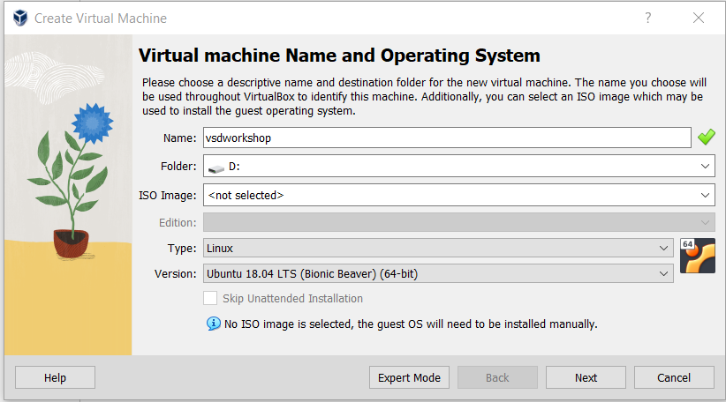

2. Giving the necessary hardware setup

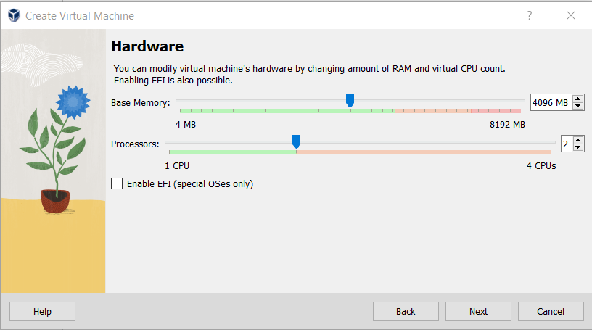

3. Setting up an Existing Virtual Disk

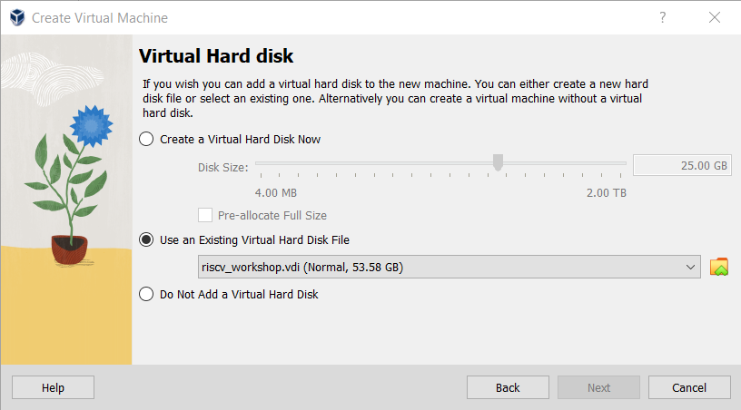

4. Completion of the Installation and Running the Ubuntu

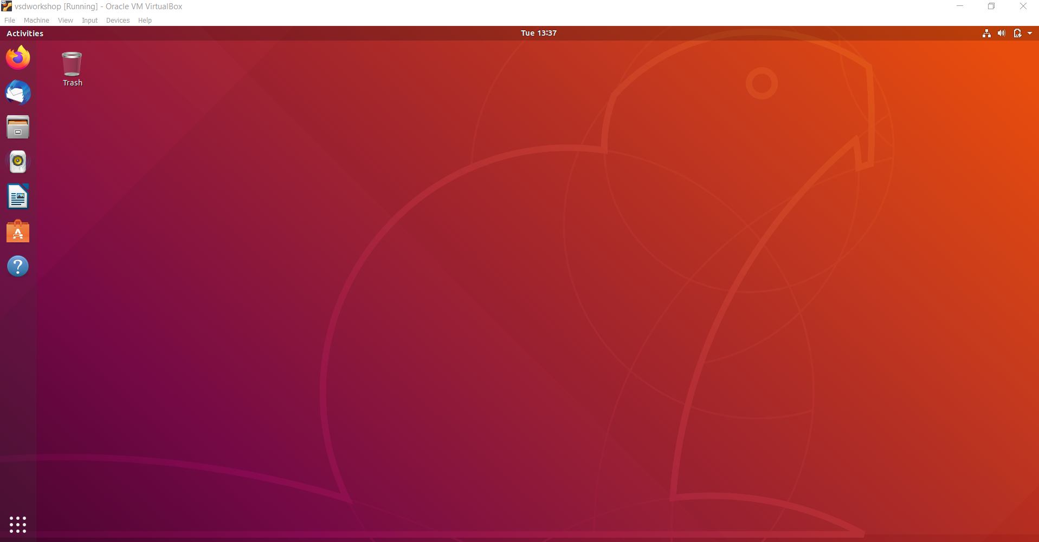

5. Writing a C code for finding sum of n number from 1 to n

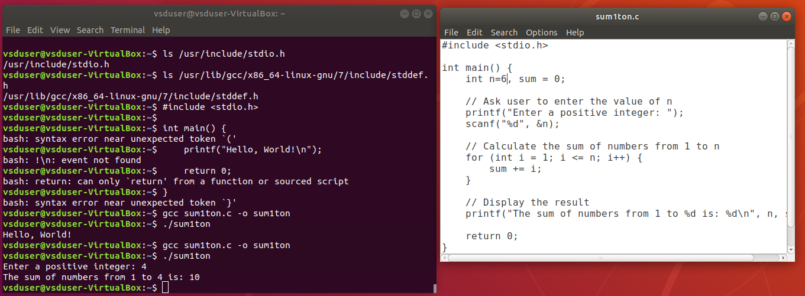

6. Converting the C code to Assembly code

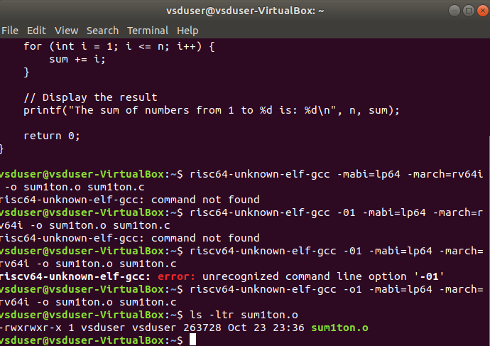

7. Result

